|  |  |  |  |  |  |
| --- | --- | --- | --- | --- | --- |
| Date | 28-Nov-22 | | | Tester Name | Janette Paus |
| Environment | Penfax - Test 2 | | | Login used | N/A |
| Operating System | Windows | Version: 21H2 | Update Number: | | |
| Software Used | Edge | Version: 107.0.1418.56 | Update Number: | | |
| Select Software | Version: | Update Number: | | |
| Application Release version | R22.4.1 | | | | |
| Test Case Title | E 18.03 | | | | |
| Test Type | Regression | | | | |
| Test Scenario | VPB Scheduled Payment to a Non-Resident | | | | |
| Expected Results | That the payment will process and tax calculation/NR4 generates correctly.  Scenario 1: Other Country Non-Resident  Scenario 2: USA Non-Resident | | | | |
| Pass/Fail | Pass | | | JIRA# | N/A |

Scenario 1: SID 249885 Other Country Non-Resident

Payroll:

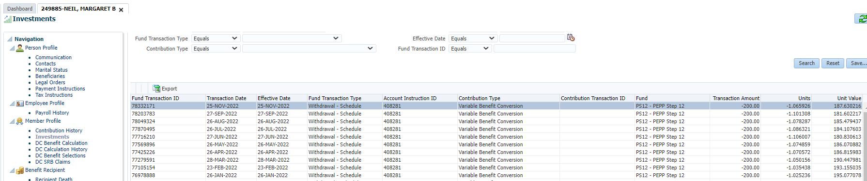

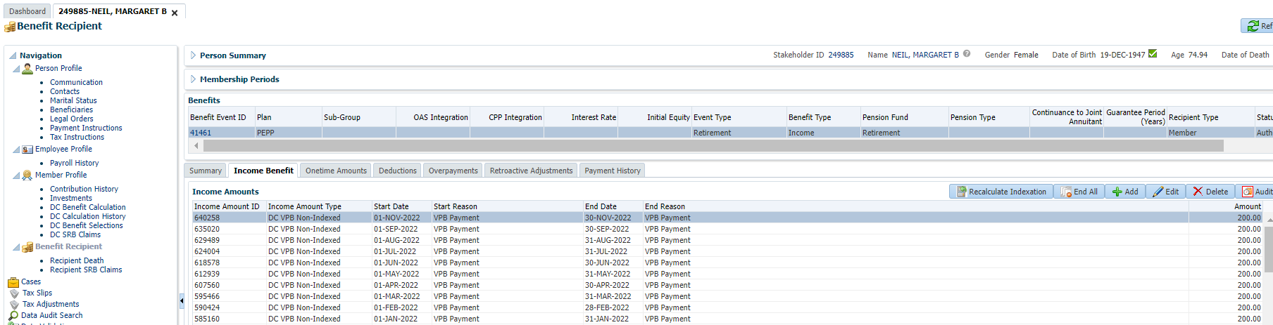

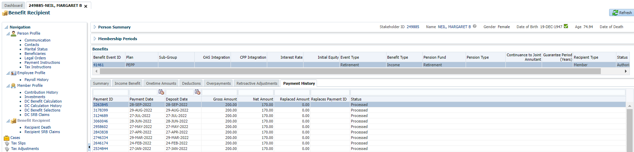

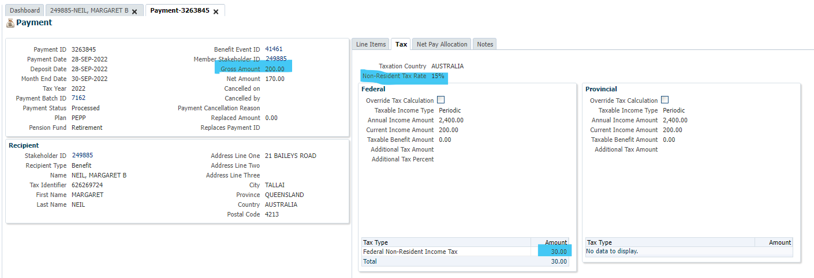

15% (or $30) non-resident tax for Australia is correct:

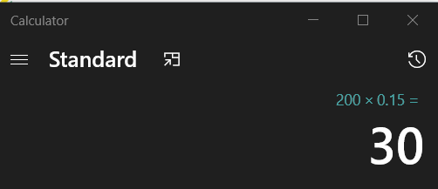

Scenario 2: SID 253805 – USA Non Resident

Payroll:

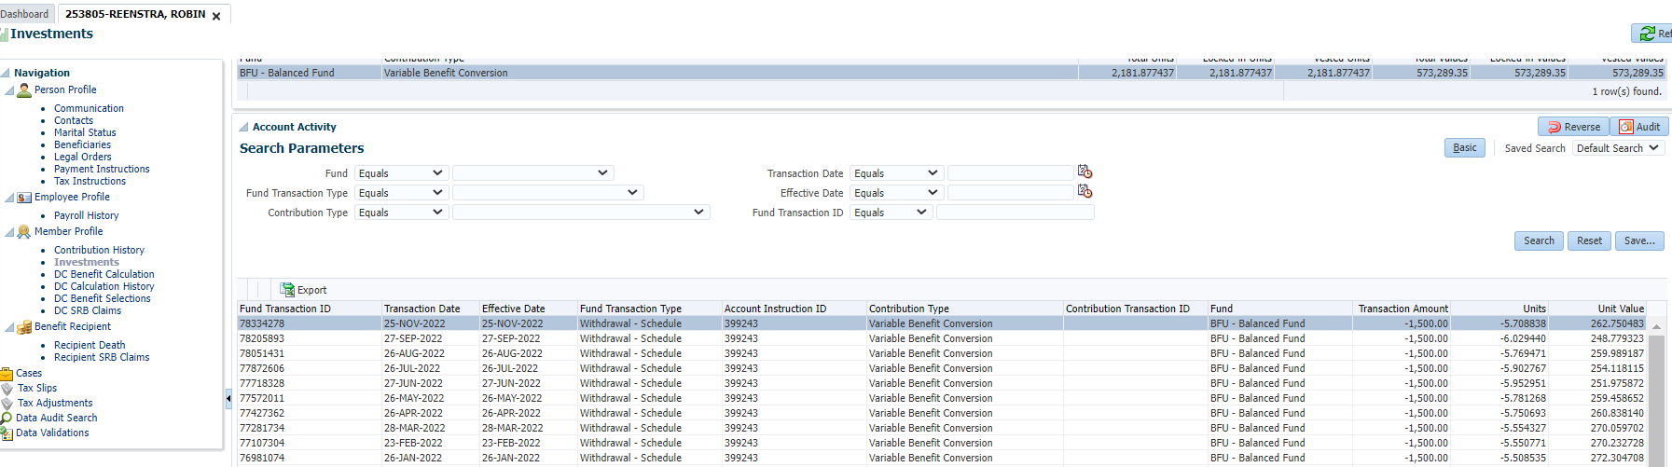

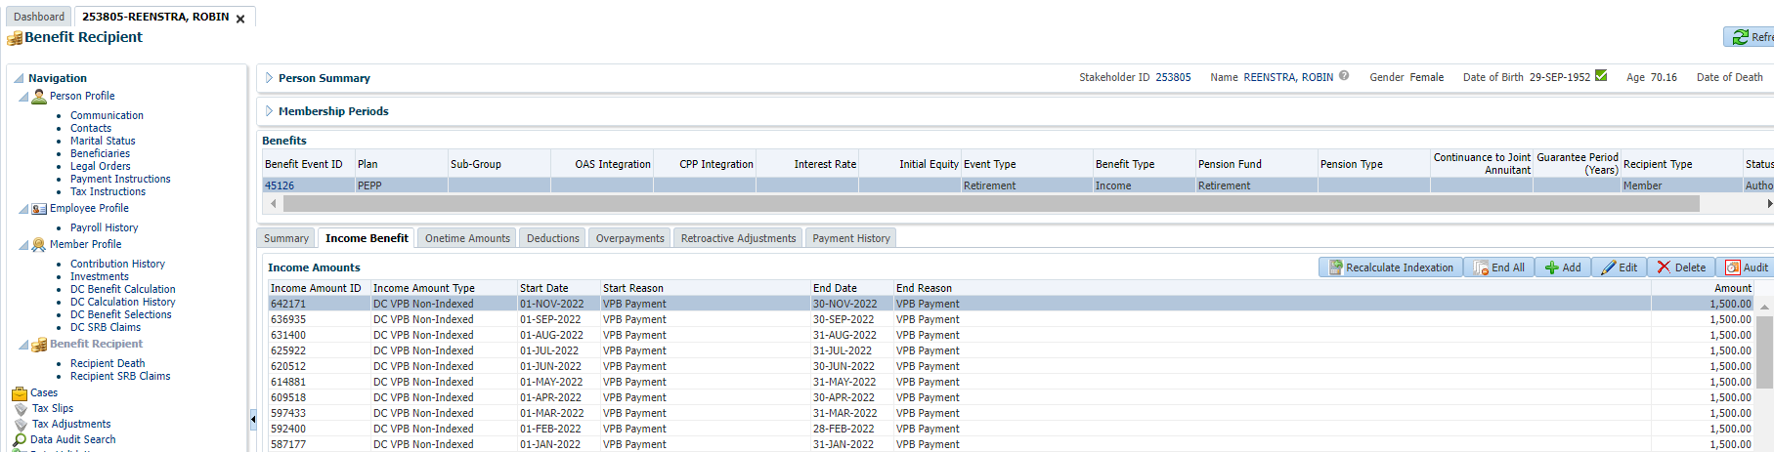

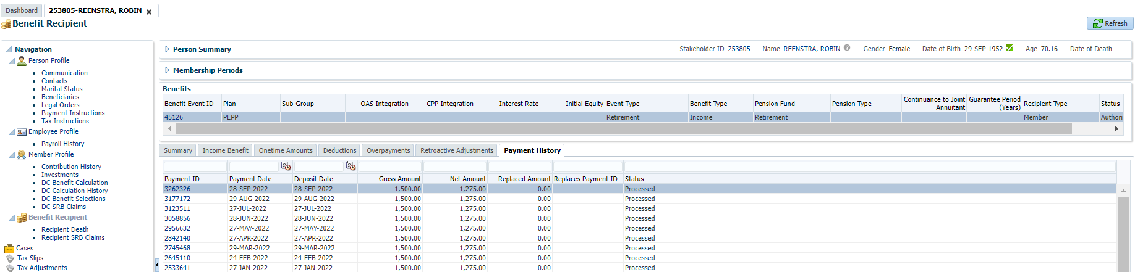

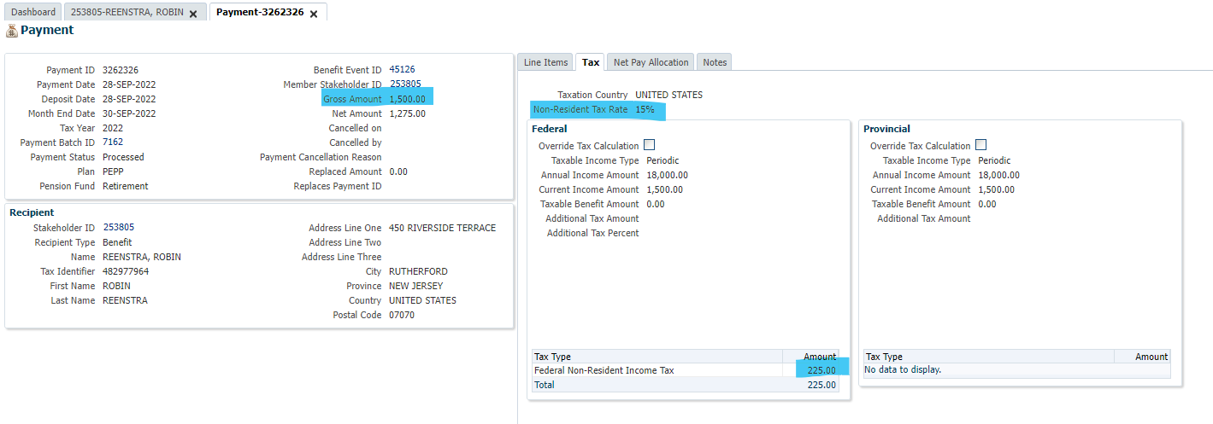

Non-Resident Tax Rate of 15% for US scheduled payments is correct.

